**WEEK 1**

**DESIGN PATTERNS AND PRINCIPLES**

**Exercise 1: Implementing the Singleton Pattern**

**Scenario:**

You need to ensure that a logging utility class in your application has only one instance throughout the application lifecycle to ensure consistent logging.

**Program**

public class logger {

private static logger *instance*;

private logger() {

System.*out*.println("Logger instance created.");

}

public static logger getInstance() {

if (*instance* == null) {

*instance* = new logger();

}

return *instance*;

}

public void log(String message) {

System.*out*.println("LOG: " + message);

}

}

import newp.logger;

public class Main {

public static void main(String[] args) {

logger logger1 = logger.*getInstance*();

logger1.log("First message");

logger logger2 = logger.*getInstance*();

logger2.log("Second message");

if (logger1 == logger2) {

System.*out*.println("Both logger instances are the same. Singleton works!");

} else {

System.*out*.println("Logger instances are different. Singleton failed!");

}

}

}

**Output**

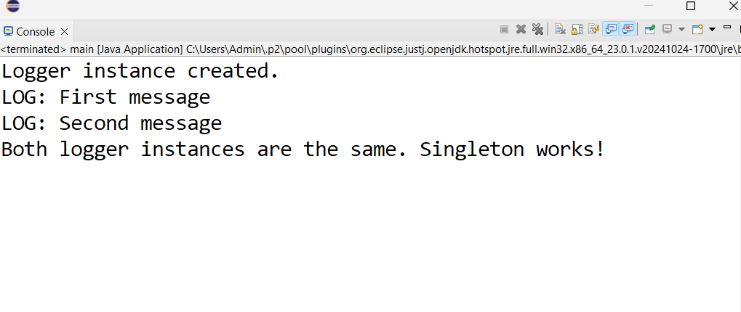

**Exercise 2: Implementing the Factory Method Pattern**

**Scenario:**

You are developing a document management system that needs to create different types of documents (e.g., Word, PDF, Excel). Use the Factory Method Pattern to achieve this.

**Program**

public interface Document {

void open();

}

**WordDocument.java**

public class WordDocument implements Document {

public void open() {

System.out.println("Opening Word document...");

}

}

**PdfDocument.java**

public class PdfDocument implements Document {

public void open() {

System.out.println("Opening PDF document...");

}

}

**ExcelDocument.java**

public class ExcelDocument implements Document {

public void open() {

System.out.println("Opening Excel document...");

}

}

**DocumentFactory.java (Abstract Factory)**

public abstract class DocumentFactory {

public abstract Document createDocument();

}

**WordDocumentFactory.java**

public class WordDocumentFactory extends DocumentFactory {

public Document createDocument() {

return new WordDocument();

}

}

**PdfDocumentFactory.java**

public class PdfDocumentFactory extends DocumentFactory {

public Document createDocument() {

return new PdfDocument();

}

}

**ExcelDocumentFactory.java**

public class ExcelDocumentFactory extends DocumentFactory {

public Document createDocument() {

return new ExcelDocument();

}

}

public class Main {

public static void main(String[] args) {

DocumentFactory wordFactory = new WordDocumentFactory();

Document wordDoc = wordFactory.createDocument();

wordDoc.open();

DocumentFactory pdfFactory = new PdfDocumentFactory();

Document pdfDoc = pdfFactory.createDocument();

pdfDoc.open();

DocumentFactory excelFactory = new ExcelDocumentFactory();

Document excelDoc = excelFactory.createDocument();

excelDoc.open();

}

}

**Output**

